
Comsats University Islamabad, Lahore Campus

Midterm Task <Lab> – SPRING 2025
Course Title | Software Testing | Course Code |  | CSE455 | Credit Hours |  |  | 3(2,1)
Instructor/s | Ms. Yella Mehroze | Program Name |  | BSSE
Semester | 8th | Batch | FA21 | Section | A | Date | March 23, 2025
Time Allowed | 1 week | Maximum Marks
Student Name | Aoun-Haider | Reg No. |  | FA21-BSE-133

Question Statement [CLO-2]; Bloom Taxonomy Level: <Applying>
Scenario:
A website needs a basic feedback form that allows users to submit their name, email, and feedback message. Submitted data should be validated and shown in a success message.

Epics
• Frontend Development
• Form Validation
• Form Submission Logic
• Testing and QA
Stories and Subtasks

Epic 1: Frontend Development
Story 1.1: Design and implement feedback form UI.
  - Subtask: Create HTML structure for the form.
  - Subtask: Style form using CSS (responsive design).

Epic 2: Form Validation
Story 2.1: Implement frontend validation for input fields.
  - Subtask: Ensure all fields are required.
  - Subtask: Validate email format.

Epic 3: Form Submission Logic
Story 3.1: Display success message on successful submission.
  - Subtask: Simulate form submission.
  - Subtask: Reset form after submission.

Epic 4: Testing and QA
Story 4.1: Manual testing of form behavior.
  - Subtask: Test with valid data.
  - Subtask: Test with invalid email.
  - Subtask: Test with empty fields.

Bug
Bug 1: Success message appears even when fields are empty due to incorrect validation trigger.
Jira Artifacts
Timeline is setup, 4 epics are added, one bug is issued and task dependencies are assigned.
. 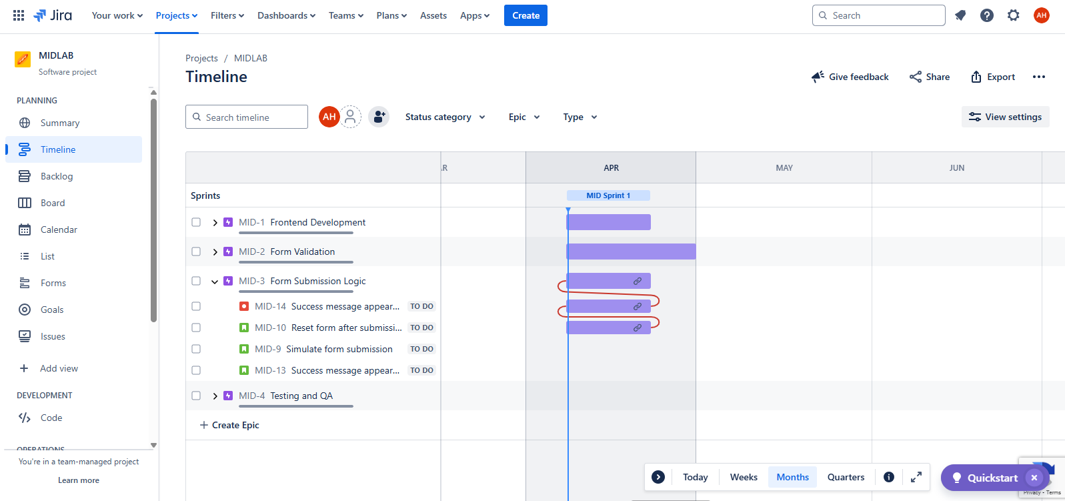

Project Setup
Sprint 1 is started with 2 weeks duration in backlog:
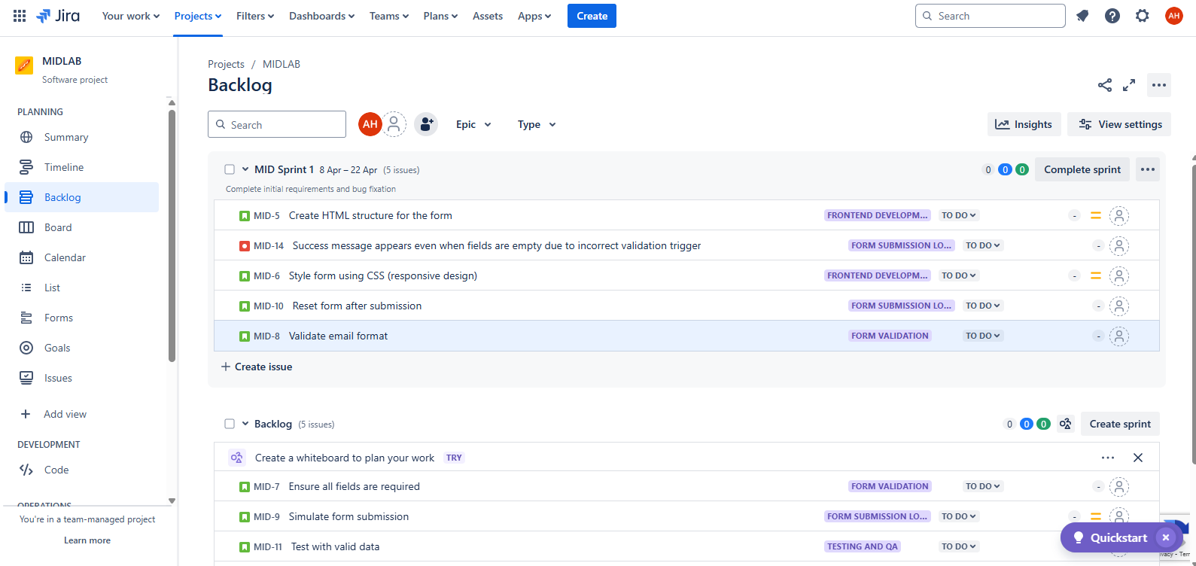
Set WIP (work in progress) limit of 3 in board
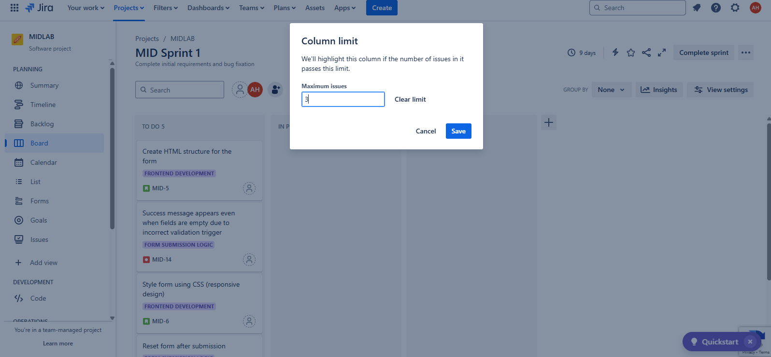
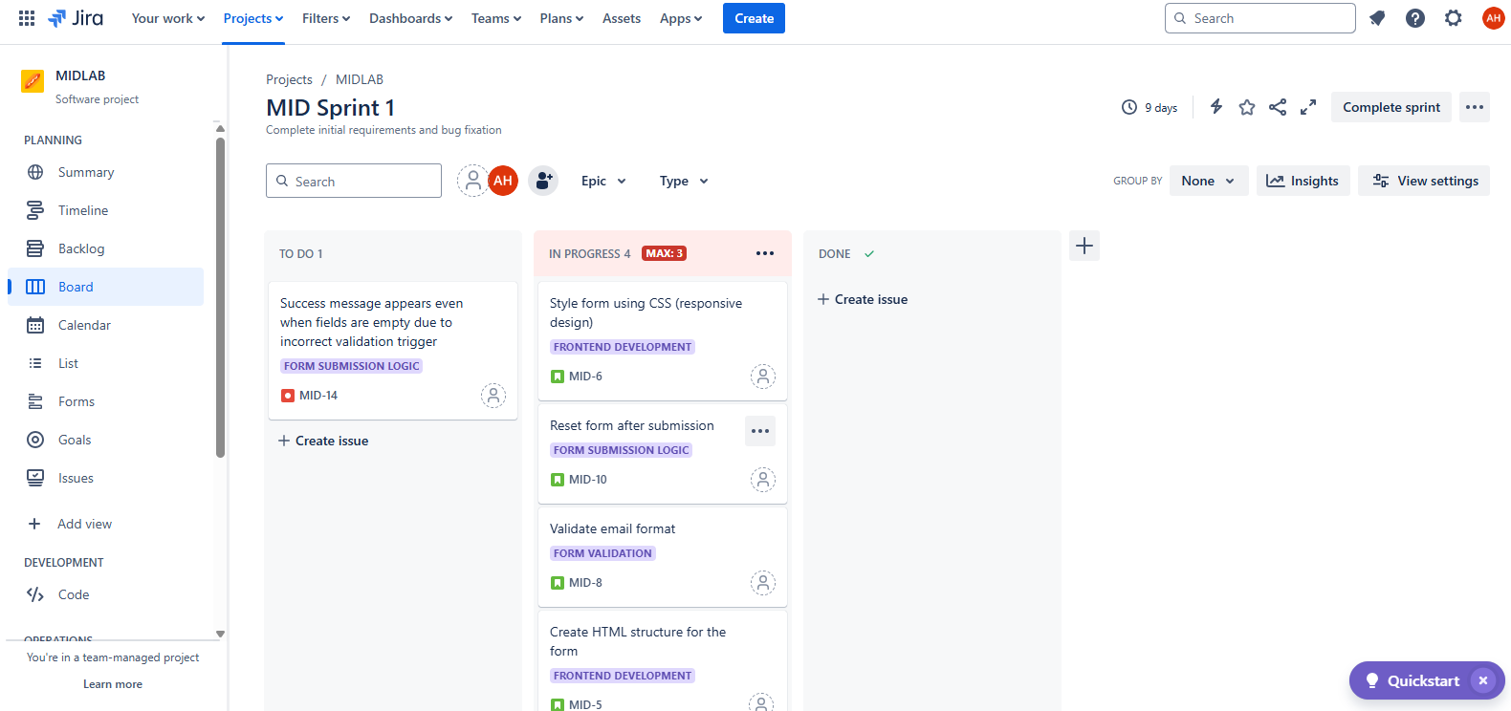
Workflow modification
I have defined the workflow that no task can be moved directly to done status.
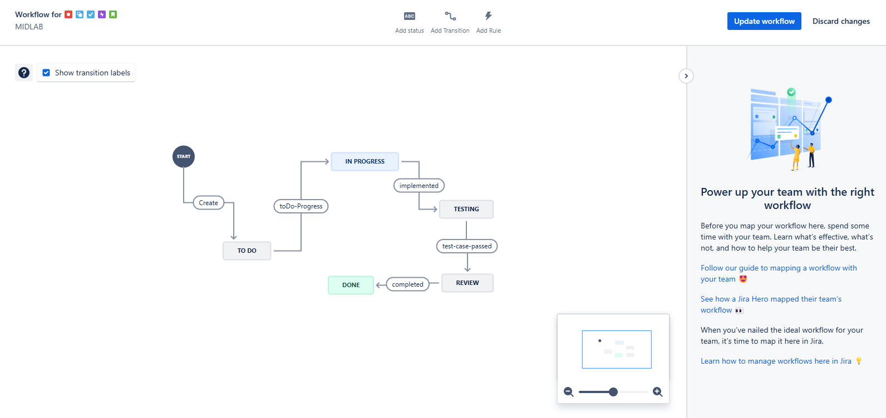

Creating a custom issue type
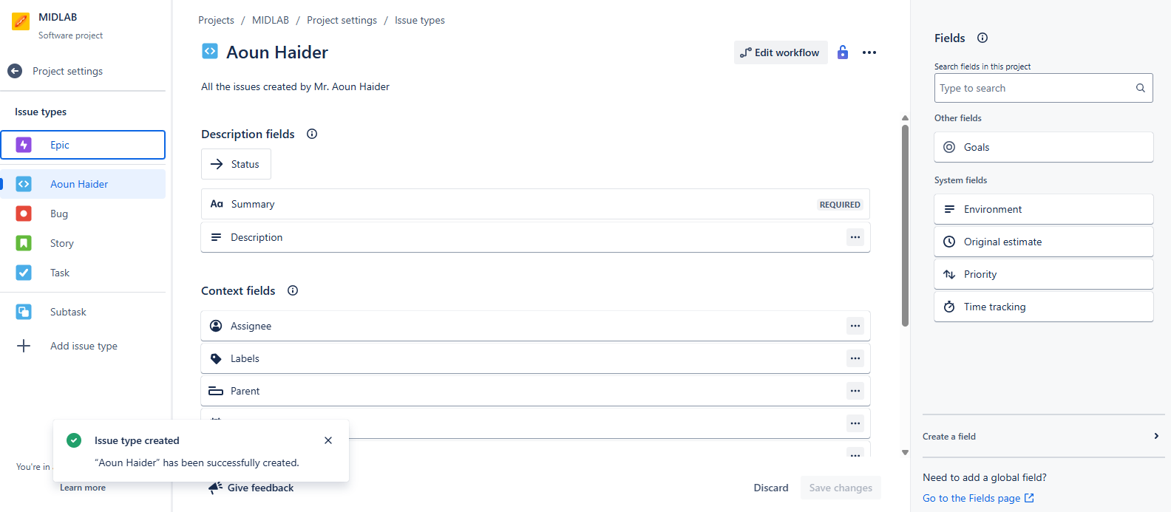
Dashboard creation
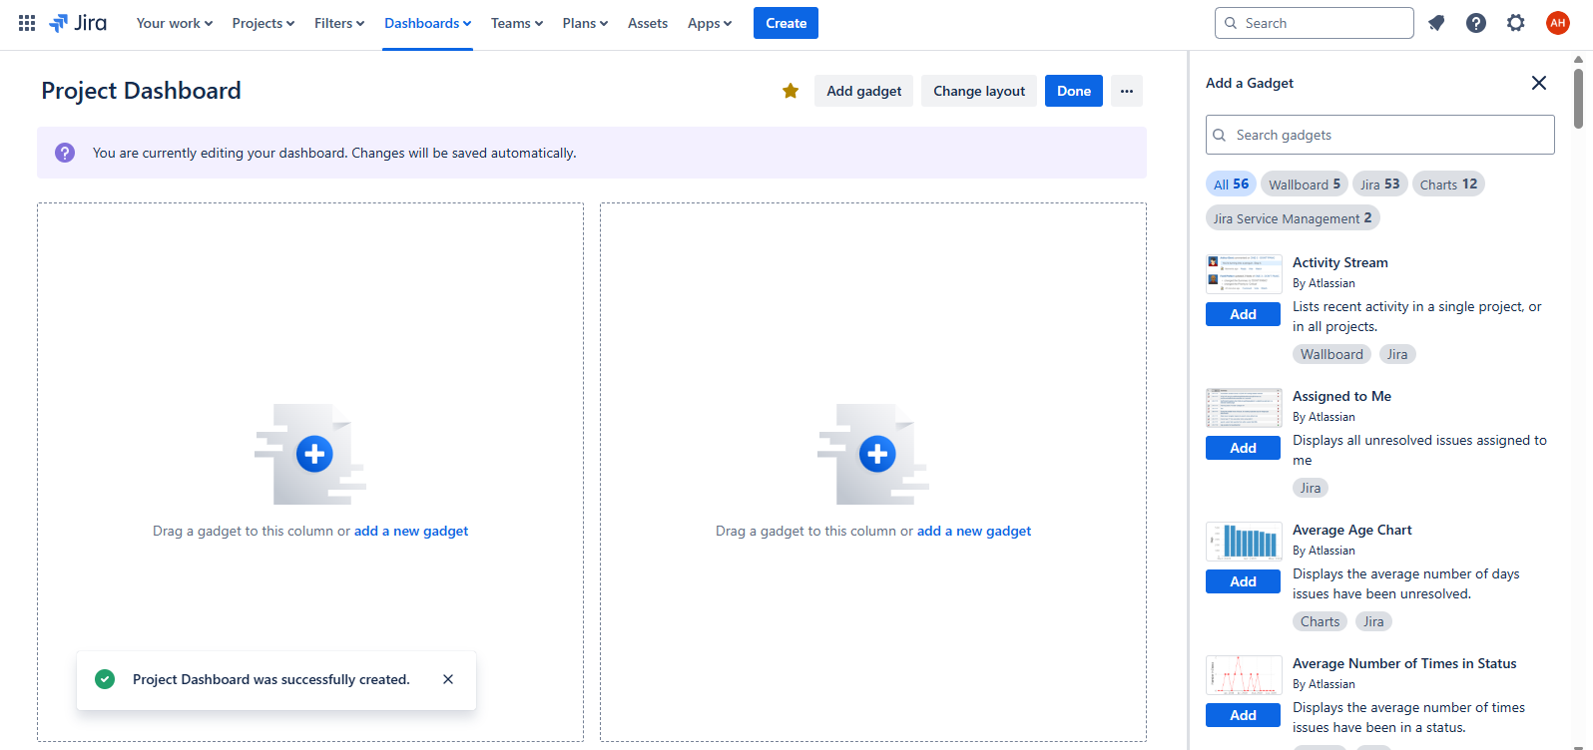
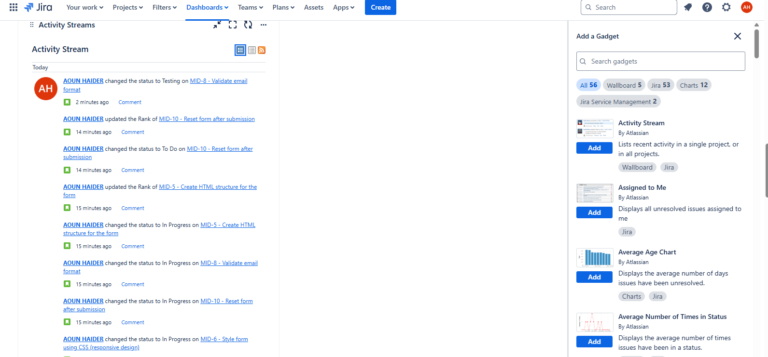
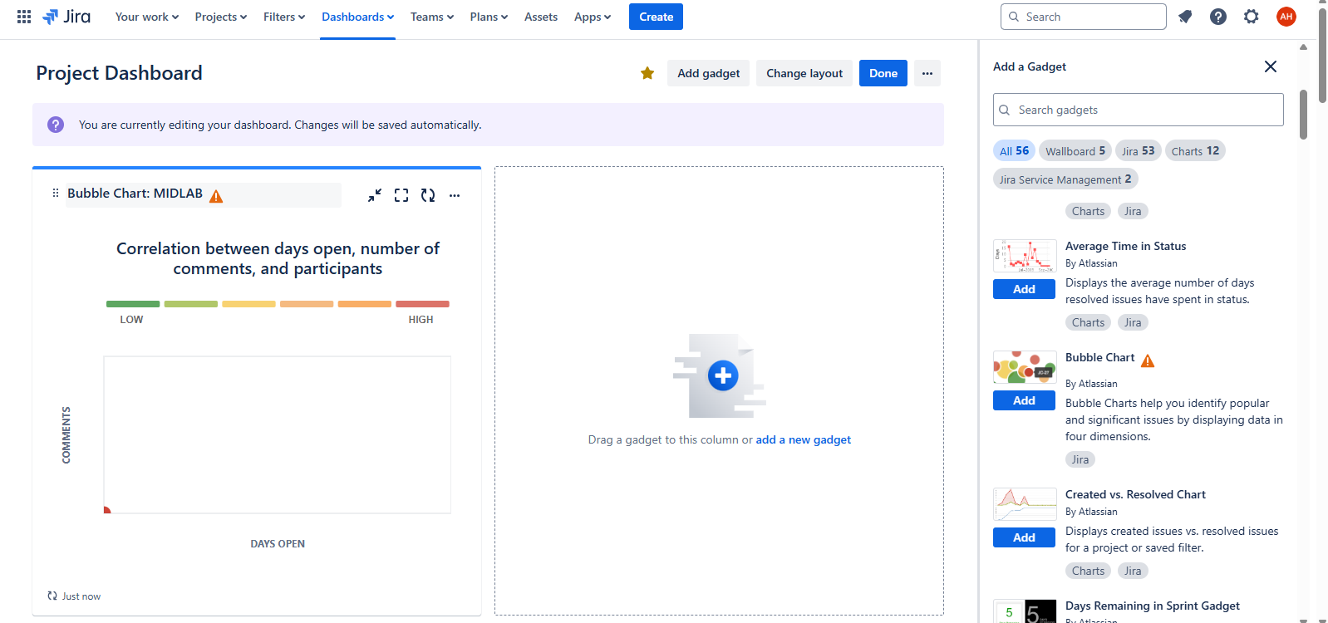
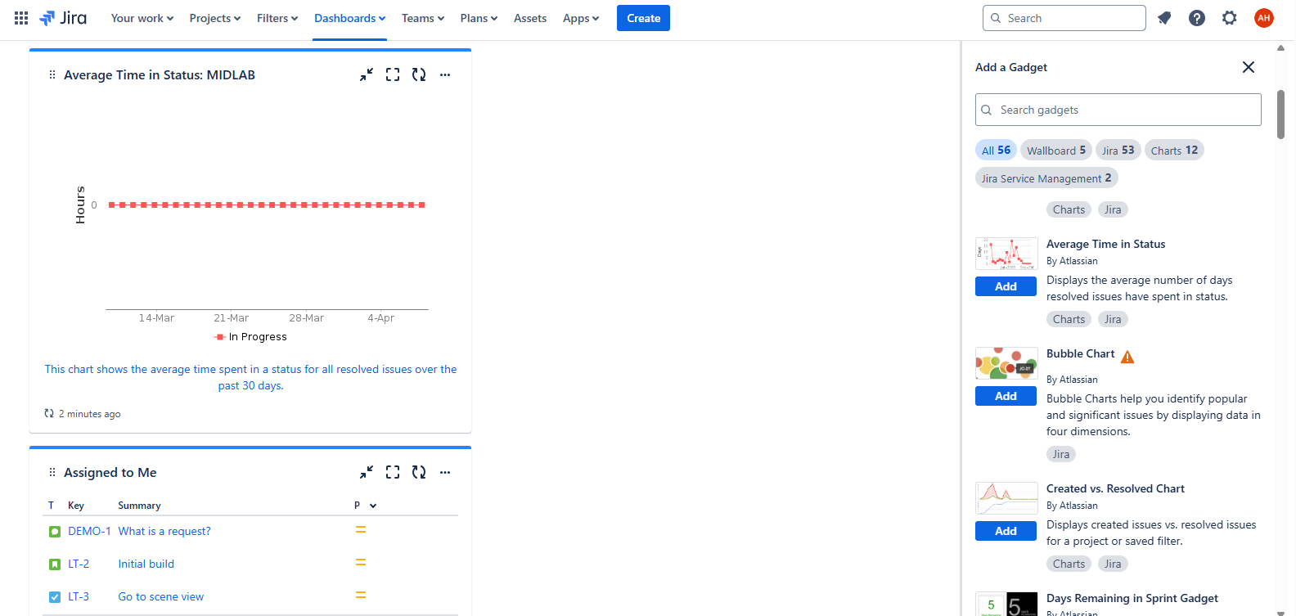
GitHub Connectivity
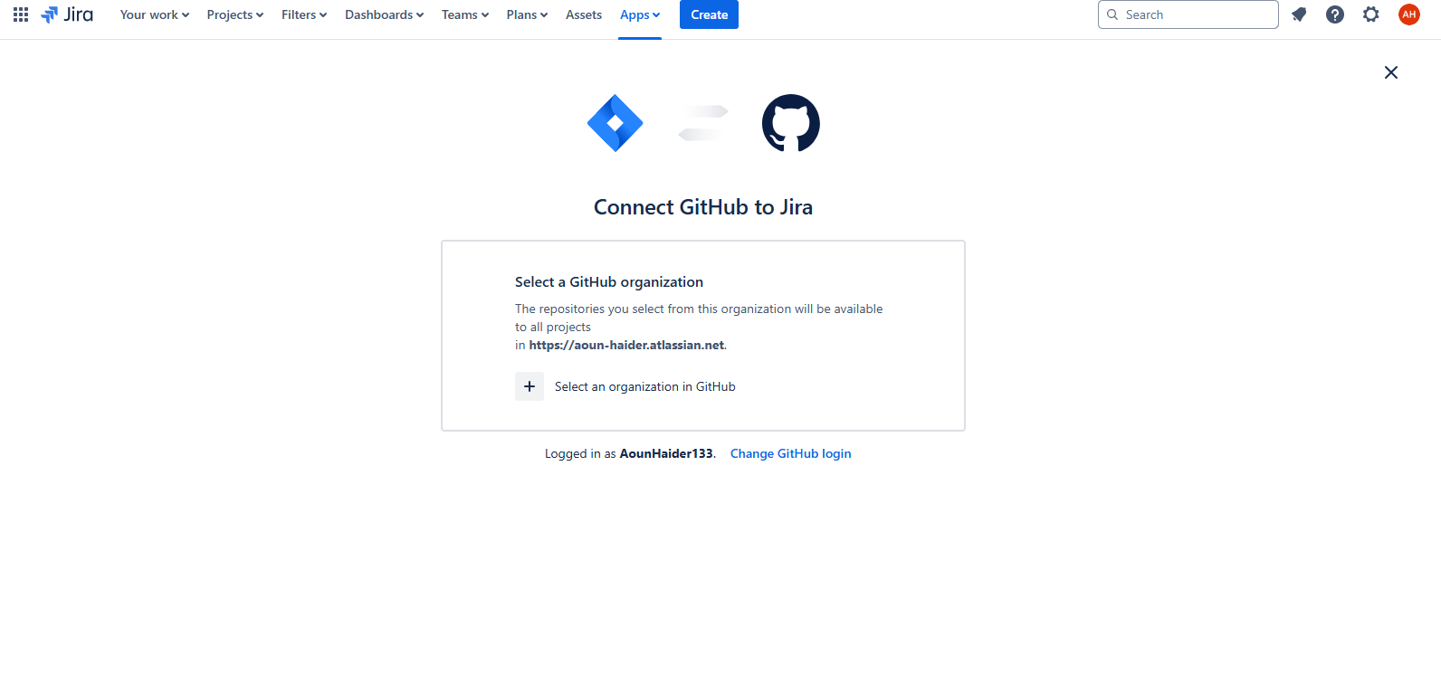

Test case and test cycle creation using Zephyr scale
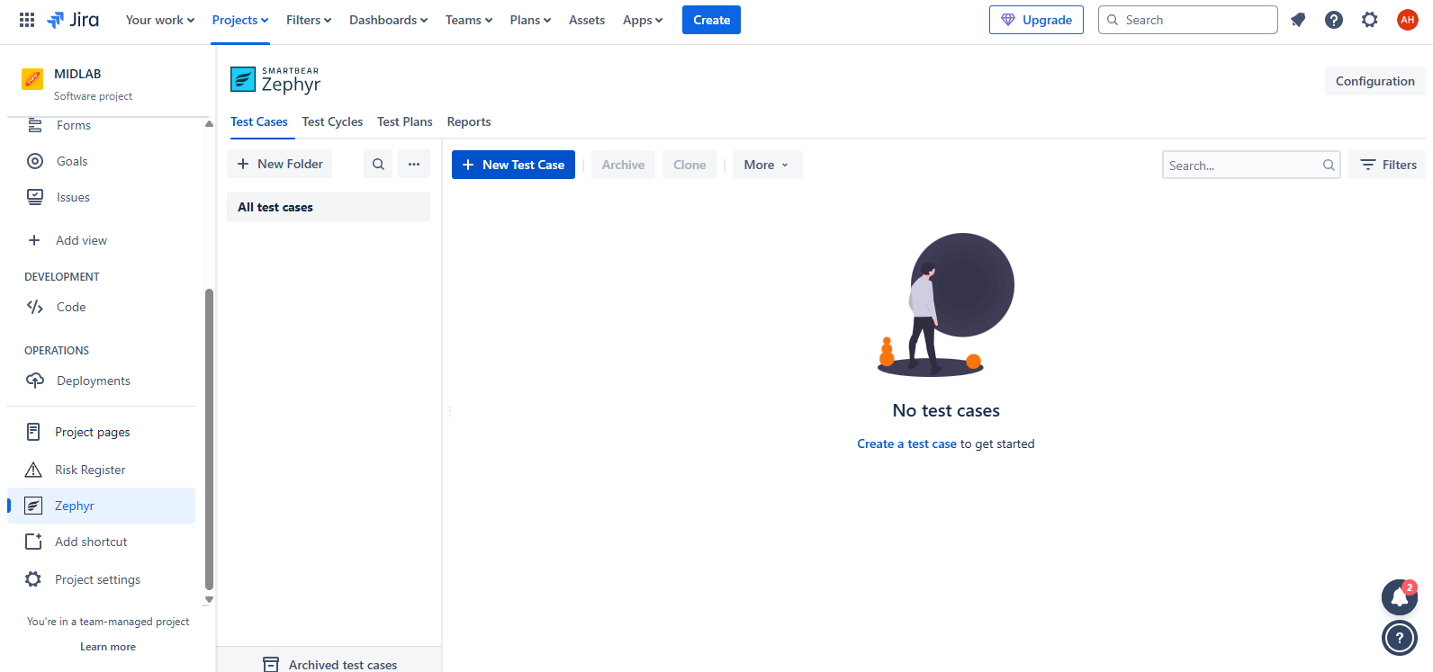
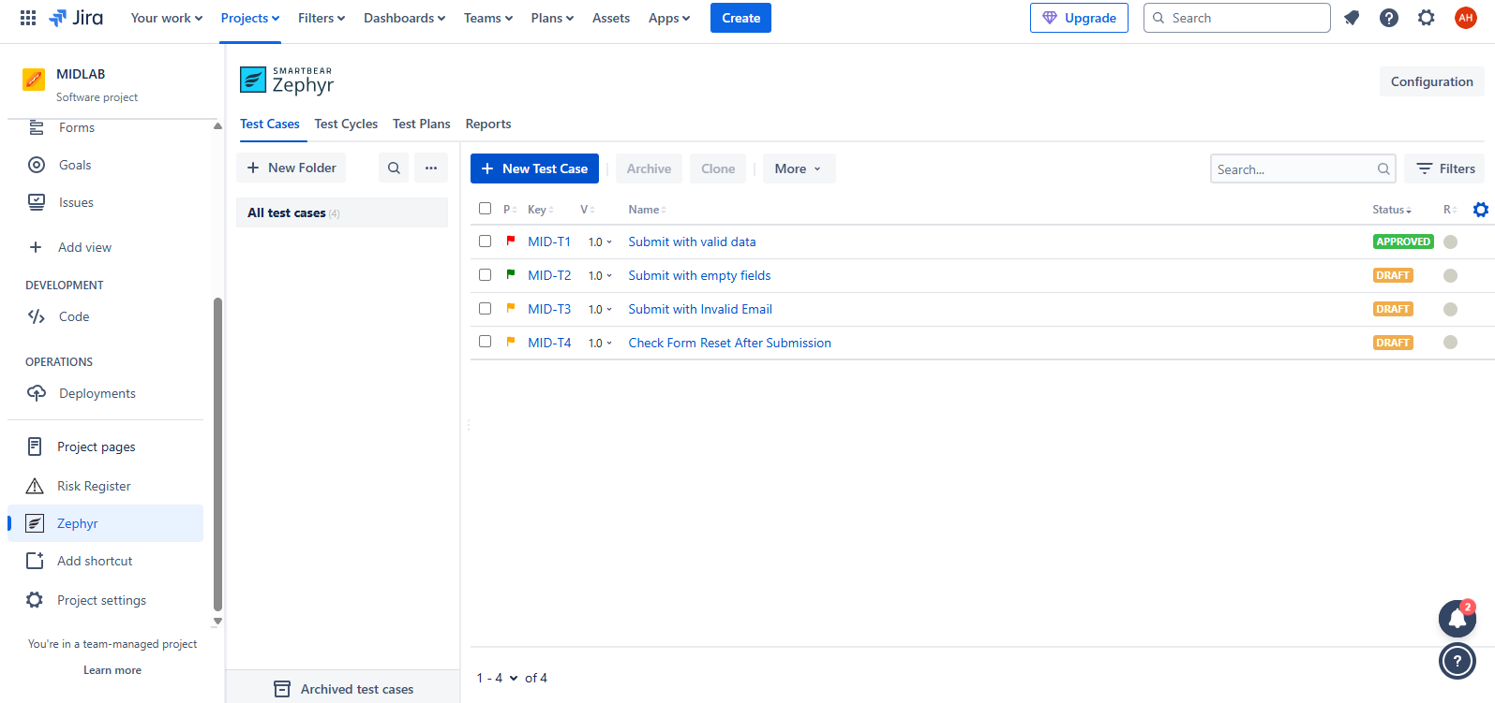
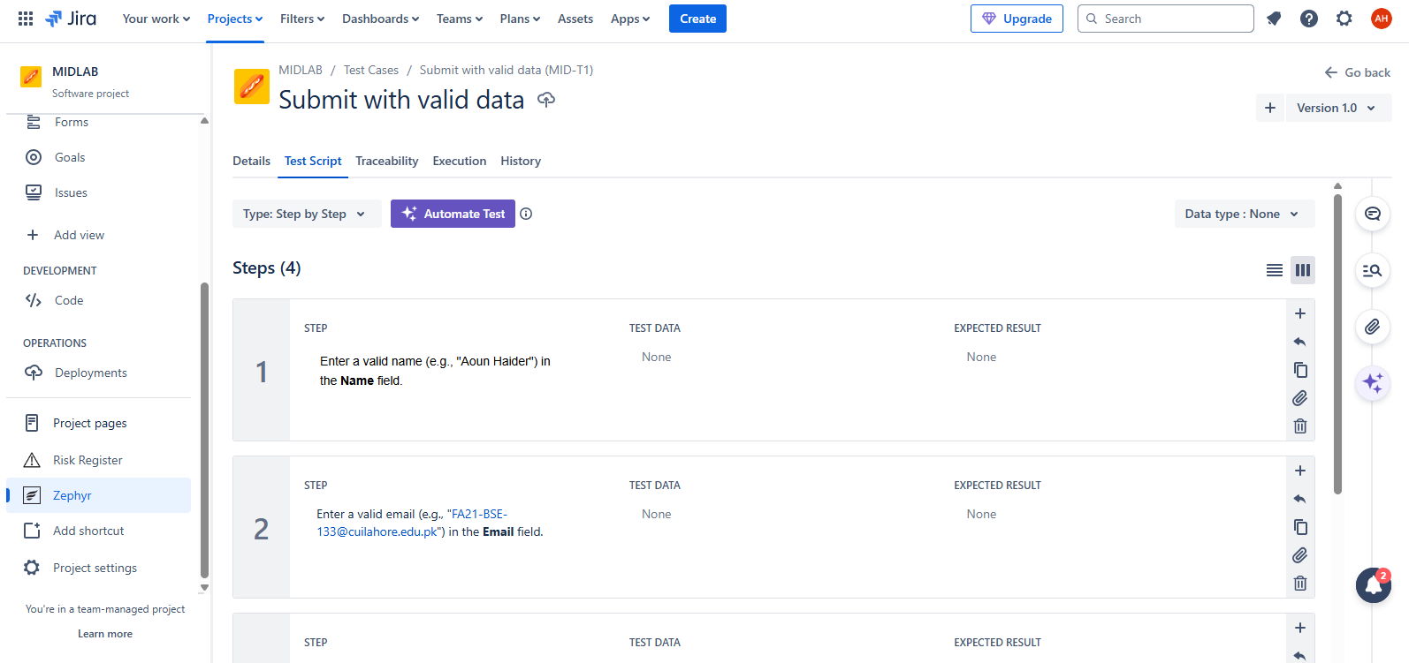
Creating custom filters
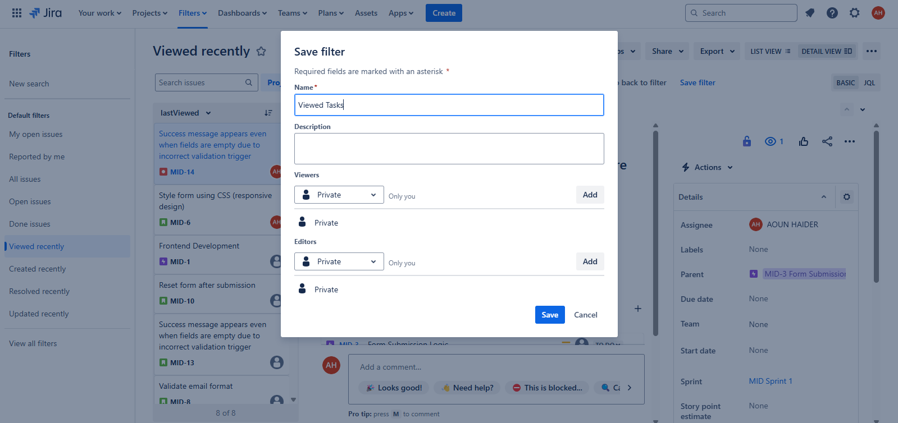
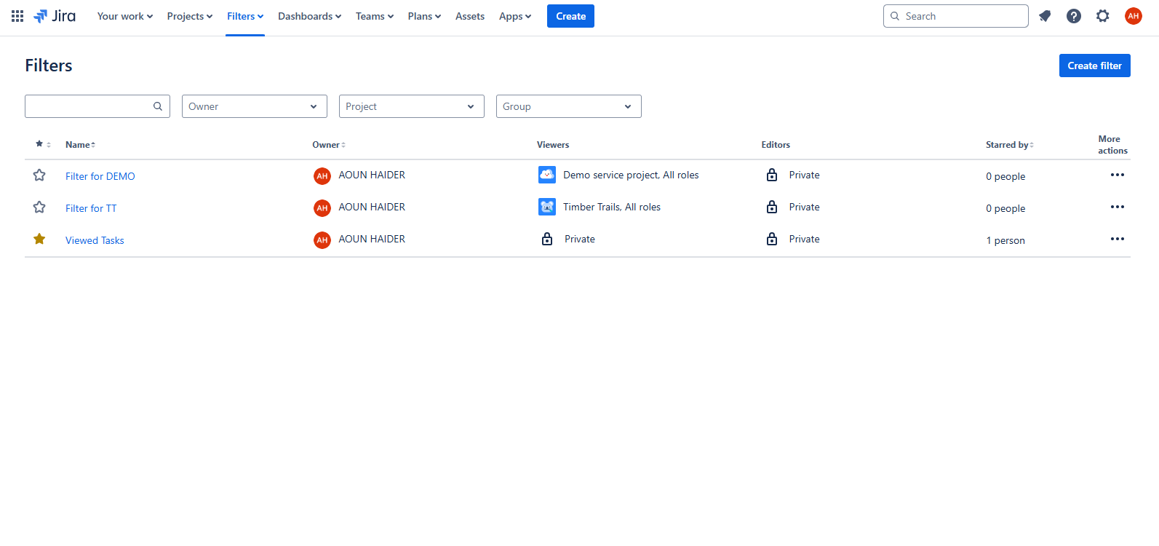
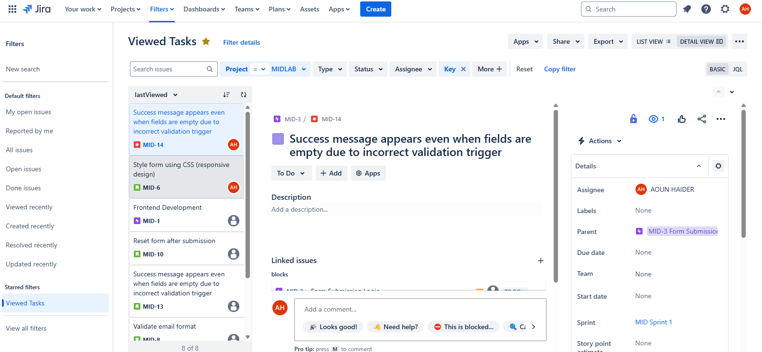
Automation creation
When a bug is moved to in progress, trigger a specific user
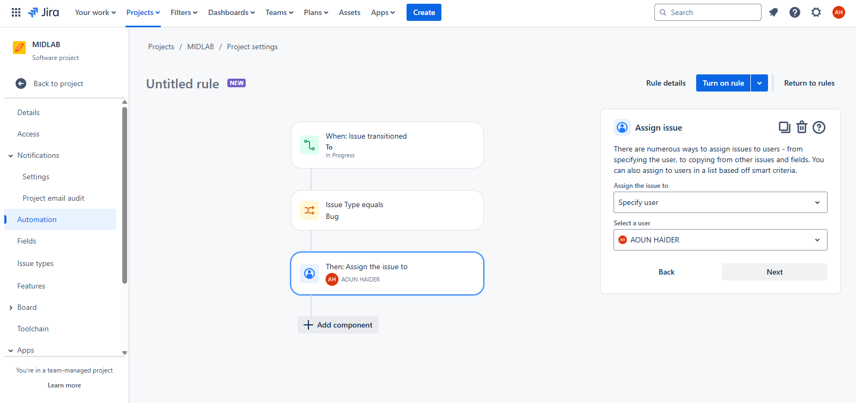
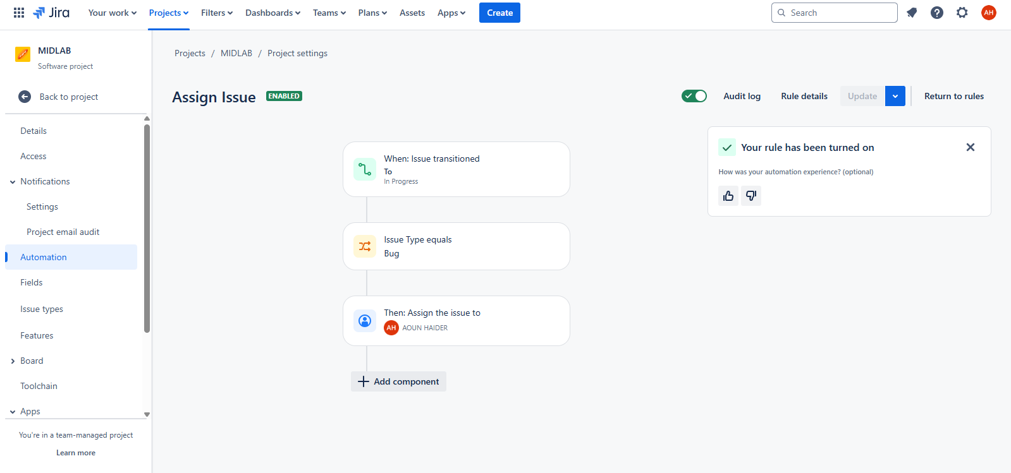
Confluence report
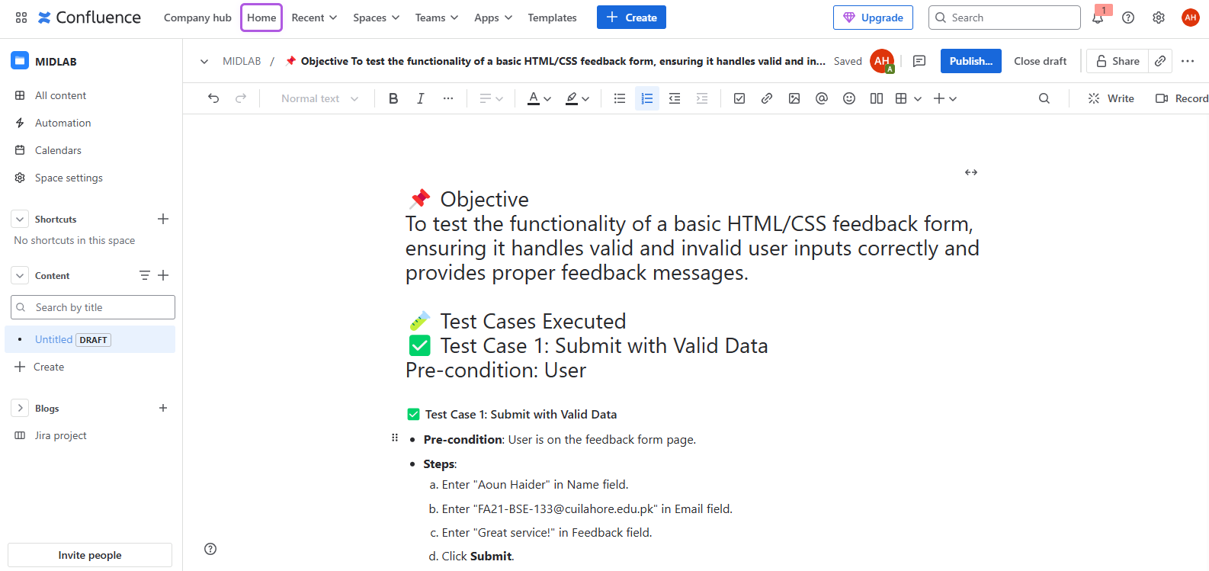
GUI
